[Impacting Performance at its Core: A Whole New World II?]

**Beyond Performance Management as an Impersonal System:**

**Targeting the Performer-Self in a Self-Regulation Practice Culture**

[Reflections by Ian Wight on the FSF 2018 ‘Exploring Performance’ Events:

Impact Heresy/A Whole New World. February 6, 2018]

‘Exploring Performance’ has become a regular feature of the [Firestarter Festival](https://firestarterfestival.com/fsf-2018/) The latest – in what has become a trilogy – flared up on February 6th, with a ‘sold-out’ pair of events: i) **Impact Heresy** – interrogating outcomes, and ii) **A Whole New World** – of action-inquiry-oriented learning communities (This latest initiative could be considered to have been fore-grounded by the 2017 experience, reported on [here](https://firestarterfestival.com/2017/05/05/lighting-a-bonfire-of-performance-measures/) )

‘Performance’ is still a burning issue, with problematic, hard-to-break-down, aspects that still seem to stick around, despite widespread sentiment to consign them to a bonfire. This year’s coordinated two-part event sought to improve performance management, and to ‘performance manage differently’, with an interest in better engaging the associated system complexity.

Elements of the system, such as outcomes - their specification, and realization – and their impact assessment, were reviewed and critiqued, but the system itself seemed to escape critical scrutiny. It was as if it was accepted as ‘a given’, not to be messed with - fundamental, foundational, fire-resistant – however ‘[misbegotten](https://facilitatoru.com/spirituality/misbegotten-systems/)’ it might be. ‘A Whole New World’ was entertained, but it too seemed to be mainly limited to the confines of the existing, ruling, performance management system – imposing, impersonal, institutional, inhumane. More of a ‘whole’ approach, to making a new work-place world, with a commensurate new ‘world-view’, might require a much bigger bonfire – to clear the ground – than some folks might have been willing to contemplate.

But there were inklings of an alternative system perspective, more attentive to: the motivation of those making up the system (those embodying it); a loosening of impersonal system controls (potentially along with greater personal autonomy); and cultivating conditions for a more learning-based (and learner-sensitive) ‘system’. This has encouraged some consideration of a reframing of the performance inquiry, to range ‘beyond performance management as an impersonal system’ in the interest of ‘targeting the performer-self in a self-regulation culture’ – assuming this itself is not immediately dismissed as ‘heresy’ [*heresy*: opinion profoundly at odds with what is generally accepted].

The two-part event situated the exploration of performance in the context of complex systems theory, aiming for some ‘outcomes’ that were complexity-savvy, and complexity-friendly. A particular class of outcomes came in for particular scrutiny (in ‘Impact Heresy’ terms), those connected to judgment and accountability – judging the efficiency and effectiveness of a programme. Other potential outcome ‘purposes’ – signaling what’s important, and learning/improvement – were acknowledged as important for targeting personal/people outcomes (rather than programme outcomes) – and these were featured more in the second part of the event (A Whole New World).

Outcomes as performance management tools - focused on judgment and accountability – were not assessed as performing well from a complex systems perspective. Outcomes-Based Performance Management (OBPM) were deemed problematic in measurement terms, and in attribution terms (For more on the critique see [here](https://sluggerotoole.com/2016/07/05/soapbox-the-sorry-tale-of-outcome-based-performance-management/) ). OBPM did not so much measure actual outcomes/impacts, as offer ‘proxy measures’ for the ‘experience of outcome’; it ‘only has metrics for what is measurable’. Attribution-wise, it was argued – from a complex systems perspective - that ‘interventions don’t create outcomes – systems produce outcomes’. Hence the ‘impact heresy’: ‘outcomes are emergent properties of complex systems’.

We then took off from this particular critique – of one form of outcomes – into an appreciative inquiry around outcomes associated with learning and improvement. This generated interesting insights for myself. I have a practice, when judgment seems to be the order of the day, to try shifting to curiosity – in effect to be inquiring, to generating questions rather than judgments, and to entertaining the prospect of dialogue, ideally – generative dialogue. Where accountability is concerned, I am particularly attracted to the notion of holding oneself to account - more precisely one’s Self, as part of an integral self-system perspective.

My curiosity was therefore piqued by the ‘impact heresy’ adjudged around ‘outcomes as emergent properties of complex systems’. For myself these are, most intrinsically, the self-systems at work within the ‘performers’ - the people performing, in their person. And if my first/prime injunction is to ‘do well by my Self’, to self-regulate well, the ‘controlling need’ of the systems I participate in might be neutralized, to mutual benefit. And if this enhances my active agency (rather than my passive system compliance) my performance may literally be transformed, into a ‘transformance’ – an ongoing transformational disposition; at the opposite end of the spectrum from mere system maintenance, from simply reinforcing a problematic status quo. This would involve learning writ large – single-/double-/triple-loop meta-learning in the moment, and ‘improvement’ in radical terms, getting at the roots of purpose.

This begins to get at ‘The Whole New World’ that I might wish to be contemplating, given my druthers. It would entail not so much ‘building a community of practice’, but building ‘a culture of practice-as-praxis’, fully embracing the complexity in everyday life. It would also entail a fundamental ‘whole-making’ impulse, an ‘ever-more-whole-making’ intent, embracing emergence, and the associated complexity. As such it would be complexity-friendly, accepting that ‘the results in complex systems are emergent’ and that ‘complex systems are not under our control’ – but also accepting that there is more to ‘life’ than ‘systems’, and that there are higher integrations where ‘we’, individually and collectively, are not without influence, by dint of our inter-relationships, and the exercise of our collective will.

Here I am activating my integral perspective, based on an application of integral theory (associated with the work of Ken Wilber). This helps me see ‘systems’ as but one of four main ‘quadrants’ of reality, along with Behaviours, Experiences and Culture/Relationships, equally privileging the worlds of (inner) Consciousness and (exterior) Form. Whole persons are implicated – Body, Mind, Heart and Soul, in terms of their Agency and their Communion, in Self, Culture and Nature. And a developmental, evolutionary, all-changes-possible, perspective is enacted – a transformation-friendly disposition to match the complexity-friendliness. This is my ‘Whole New World’.

The second-part of the ‘exploring performance’ inquiry provided indications of some openness to such an integral perspective. There was a call to embrace the complexity of life, the ‘inter-twining’ of complexity and relationships, the conjoining of motivation and learning, and the concern with quality of ‘system health’. For example, motivation was rendered as intrinsic (not extrinsic); it is an interior relational condition, rather than simply a function of exterior transactions. Learning via reflective practice, including a ‘positive error culture’ was acknowledged as ‘a driver of improvement’ – a valuing of inner work in/on the person, to support outer work in/for the world.

‘System Health’ was represented in terms of ‘taking responsibility for the health of the system as a whole’, with a focus on ‘networks’ (rather than organizations), on nurturing trust, and positive inter-relating. For myself, this represents a healthy platform of possibilities for taking ‘performance’ to a whole new level: performer-driven – a performer ‘growth and development’ culture. These would be ‘[networks of hope](https://www.linkedin.com/pulse/identify-networks-hope-power-prompt-ian-wight/)’ , constellating ‘[circles-of-trust](http://www.couragerenewal.org/approach/)’, evidencing robust (personal) [vulnerability](https://www.brainpickings.org/2016/04/11/david-whyte-vulnerability/) and well-held (communal) vulnerability; not simply learning communities, but learning cultures valuing the attainment of personal [*praxis*](http://integralleadershipreview.com/12587-215-practice-praxis-transformative-education-leading-integralprofessional-interface/) and collective [*ethos*](https://www.researchgate.net/publication/289073537_Exploring_inter-being_and_inter-becoming_as_ethos-making_The_integrally_informed_pursuit_of_professional_community_well-being). Encouragingly, the research reported in ‘[A Whole New World](https://collaboratecic.com/a-whole-new-world-funding-and-commissioning-in-complexity-12b6bdc2abd8)’ indicated elements of a responsive emerging organizational ethos around: a ‘whole-person’ approach; a ‘bespoke response to individual need’; devolved decision-making ‘to the front line’; and creating learning systems, with the afore-mentioned ‘positive error culture’.

We had an opportunity, in discussion groups, to consider how such a culture could be enabled. The ‘letting-go’ of an authoritative ‘command and control’ fixation was perceived as potentially ‘letting-come’ new waves of creativity, innovation and improvisation. I sensed this might entail more attention to common ‘purposing’ and concerted ‘ethos-making’. In terms of new ‘funding and commissioning’ possibilities I envisaged the mobilization of new/additional forms of ‘capital’, and an extending of ‘bottom-lines’, along with the notion of reworking commissioning into ‘co-mission-ing’ (common missions that folk could rally around). I wondered too about the prospects for ‘compounding trust’, as the underlying ‘interest’.

The final activity was an ‘open space’ opportunity for more in-depth discussion of particular themes, according to personal interest – considering ‘how can we build more complexity-friendly ways of working’? The themes on offer were: Trust; Leadership and Cultural Change; Data/Evidence; Accountability; and Learning Systems (There was a call for additional themes for two other slots, and I nominated ‘Vulnerability’ – but there were no takers, other than Toby Lowe, and one other person who expressed keen interest, but who had to leave early).

Personally, the two-part session was very informative, provocative, stimulating and generative. I was left wondering where I might usefully contribute further – especially if there is another performance inquiry at the next Firestarter Festival. From my integral world-view I have a couple of hunches – about possible lines of exploration. These involve reframing the recent ‘impact/outcomes’ interest in terms of a wider framework that may open up new avenues of discussion, and a consideration of the alternative perspective represented in the title/sub-title of this offering, that may shift the focus from that of performance management systems to that of performer-based self-regulation in the context of a praxis culture. These engage some recent integral theory applications that point to the possibility in: common purposing (interior I/We work); healthy culturing (interior collective work); optimum ‘system-ing’ (taking an integral view of systems); and dedicated ‘person-ing’ (valuing ‘personal’ over ‘individual’). Self-awareness, as well as more sophisticated system-awareness, looms large; the territory of consciousness is admitted to the discussion.

In terms of reframing impact/outcomes (and more besides), the Meta-Integral Foundation’s work on a meta-capital/meta-impact framework identifies four types of impact, ten forms of capital, and four bottom-lines <http://www.metacapital.net/>

**Four Impacts~Ten Capitals~Four Bottom-Lines**

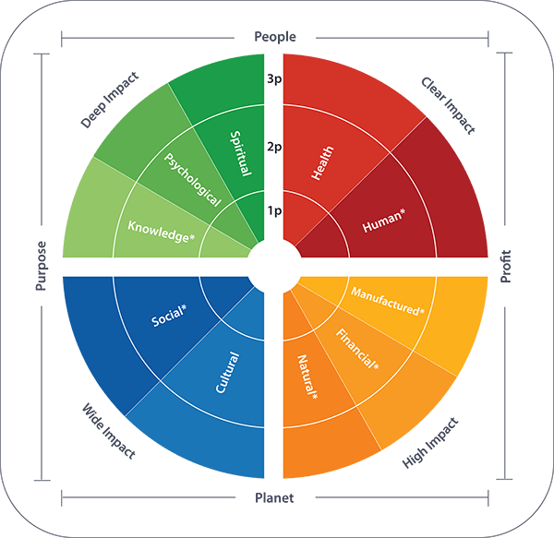

<http://www.metacapital.net/>

‘Impact’ is described in terms of **Clear Impac**t (change in stakeholder performance); **High Impact** (stakeholder systems); **Wide Impact** (stakeholder relationships); and **Deep Impact** (stakeholder experience). Each ‘impact’ quadrant is associated with particular ‘capitals’. For example, Deep Impact is associated with Spiritual, Psychological and Knowledge Capitals, and Wide Impact is associated with Social and Cultural Capital. And all of these are associated in particular with the **Purpose** bottom-line, which captures the various forms of value associated with individuals and collectives cultivating purpose.

In terms of a performer-based (self-regulation) praxis culture, this may be prospected in the work of Robert Kegan et al in the book [*An Everyone Culture*](http://waytogrowinc.com/an-everyone-culture)Conceptually, the book is structured their around three elements of a DDO (a deliberately developmental organization) - in terms of depth, height and breadth: the depth of its ‘developmental communities’ (what they call ‘*home*’); the height of its 'developmental aspirations' (what they call its *edge*); and ‘the breadth of its 'developmental practices' (which they call its *groove*)’ (p. 85). For more extensive discussion, and selected extracts, see Appendix 1.

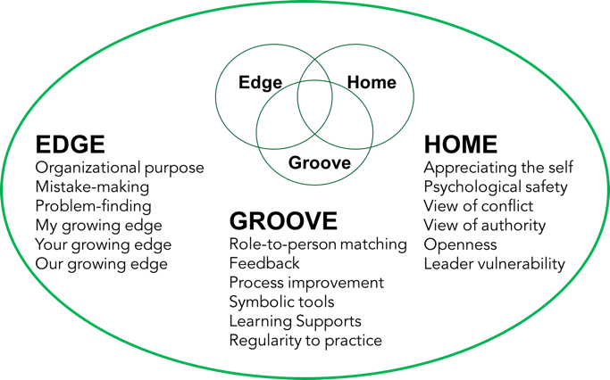

<http://www.waytogrowinc.com/>

The main setting for practice is ‘Groove’, allowing for an insightful elaboration of practice, and practicing – especially vis-s-vis ‘performance’. Of particular interest is the aspect of ‘admitting the interior to the world of what is manageable’ … inner experience is placed ‘in-bounds rather than out-of-bounds in the life of work’… ‘routine practices openly encourage, and seek to make regular room for, the personal and the interior, on behalf of explicitly welcoming the whole person into work every day’.

Of particular relevance here is the observation: ‘The culture of most organizations is not designed for practice; it’s designed for performance’. The contrast made is with ‘a culture of practice’ … ‘everyone is learning and growing’. It is a culture that is … ‘helping people adopt the spirit, intentions, and mind-set of practice, rather than those of performance’. It is a practice culture, rather than a performance system, that is being emphasized.

I am wondering if this ‘contrasting' can be usefully pushed further, into the realms of *transformative* practice (in comparison with essentially performative ‘practice’).

It could be speculated that DDOs enact as a 'transformance system’ (rather than in conventional performance system terms), and merit reference in terms of their ‘transformativity’ (rather than performativity). The operative practice culture appears to value a particular form of agency, which I have termed ‘transformency’ [(in a 3T Transformation context)](https://www.researchgate.net/publication/319903313_Transformers_Transforming_Transformatively_Inquiring_into_Our_Competency_for_Transformency), with the associated ‘transformencies’ as essentially cultural, and inter-personal (rather than behavioural and individual). They can be conceived as synergistic, enacting the ‘every-one-ness’, compoundingly; a form-transcending consciousness may be at work.

There is also the integrally-informed work of Tam Lundy on self-regulation, for the [Canadian Self-Regulation Initiative](http://www.self-regulation.ca/perspectives/self-regulation-integrating-four-essential-perspectives) While much of the focus of this work is on children in school settings, it could be adapted and developed to focus on adults (the performers) in work-place settings.

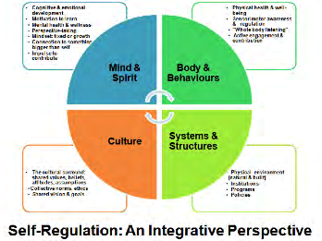

<http://www.self-regulation.ca/perspectives/self-regulation-integrating-four-essential-perspectives>

My own work here, in the context of U Lab/Presencing, may also be relevant for fostering the necessary professional-self design, for the development and growth of public service professionals. [See this FSF2018 offering](http://ianwight.ca/uwork-your-you-at-work-explorations-in-the-application-of-u-theory/).

**Appendix 1: Extracts from ‘An Everyone Culture’**

Robert Kegan et al 2016. *An Everyone Culture – Becoming a Deliberately Developmental Organization* Harvard Business Review Press

‘DDOs live out their developmental principles through an immersive and seamless set of practices, which we call its groove’…‘These practices represent another set of discontinuous departures from the routines, language, and structures of most organizations… they are the practical means by which people, at every level, engage their growing edge’ (98). The authors identify ‘four underlying dimensions’ to the ‘groove’ they found in the DDOs they studied (destabilization can be constructive; mind the gaps; set the time scale for growth, not closure; and the interior life is part of what is manageable). The latter is particularly intriguing:

“In the ordinary organization, the things that are valued are those that are tangible and outwardly visible. It’s no surprise, then, that leaders direct their attention to those things. Understandably, operations refers exclusively to external behaviours and visible processes on behalf of collective and individual key performance indicators, deliverables and goals, serving external strategies. In contrast, for a DDO, interior operations - internal behaviours, patterns of thinking, and psychological processes (especially those for managing difficult emotions) - are no less real for being intangible or invisible” (106).

“Admitting the interior to the world of what is manageable does not mean that leadership aspires to a form of intrusive mind control or psychotherapy. Rather, it means that the culture as a whole, and each individual within it, places inner experience in-bounds rather than out-of-bounds in the life of work: planning, strategizing, operations, execution, performance enhancement, process improvement - all these business functions are carried out by people who come to them with their whole selves. DDOs explicitly uncover and overturn the customary pretence that work is public (i.e. external), the personal is private (i.e. internal), and the personal should not be part of work” … “routine practices openly encourage, and seek to make regular room for, the personal and the interior, on behalf of explicitly welcoming the whole person into work every day” (106).

The book’s Chapter 4, ‘In the Groove’, focuses on the 'practices and practicing to create an everyone culture’. It articulates a DDO’s particular approach to practice, and practices: ‘We refer to all the developmental tools, habits, formalized behaviours, and types of meetings in DDOs as *practices*, because the word reminds us that we’re doing something in a certain spirit, with a particular intention’ (123).

“Consider what it means to practice, to have a practice, and to be practicing. Perhaps the central idea is that we’re doing something repeatedly, with the intention of becoming better at it. In other words, when we’re practicing we are not expecting (and others are not expecting) to perform perfectly. In naming what we’re doing *practice*, we signal that we’re experimenting, trying something on, working at improving. And we clarify that practice is what we’re supposed to be doing - trying hard at something to get better at it. We’re creating conditions in which we won’t feel pressure to demonstrate expertise, conditions that will allow us to experiment, that will allow us to gather feedback, that will help us learn’ (124).

‘*Practice* also suggests we’re doing something routinely, regularly, as a normal part of our lives. We think that the way to get better at something requires us to make learning it part of our routine. We expect to be practicing today, tomorrow, and on into the foreseeable future. Although we are trying to become proficient, we never reach completion. Our practicing, and therefore our learning, never stops’ (124)

‘The culture of most organizations is not designed for practice; its designed for performance. Everyone is trying to look good, display expertise, minimize and hide any mistakes or weaknesses, and demonstrate what they already know and can do well. In a culture of practice, in contrast, everyone is learning and growing’ … it’s not sufficient to give people time and space and rules for practicing. You must also pay attention to creating a culture of practice, helping people adopt the spirit, intentions, and mind-set of practice, rather than those of performance’ (124).

The authors make much of the contrast between a focus on *practice* (in a DDO) vis-a-vis a focus on *performance* in ordinary organizations. It is a practice culture, rather than a performance system, that is being emphasized. I am wondering if this ‘contrasting' can be usefully pushed further, into the realms of *transformative* practice (in comparison with essentially performative ‘practice’).

It could be speculated that DDOs enact as a 'transformance system’ (rather than in performance system terms), and merit reference in terms of their ‘transformativity’ (rather than performativity). The operative practice culture appears to value ‘transformency’, with the associated ‘transformencies’ as essentially cultural, and inter-personal (rather than behavioural and individual). They are synergistic, enacting the ‘every-one-ness’, compoundingly; a form-transcending consciousness at work [see associated musings below*, within the context of a ‘prefix’ inquiry].

This very much takes us into ‘the interior life’, the in-goings that condition the out-comings. The authors tease this out in terms of particular ‘qualities of practicing in a DDO’ - several 'deeper commonalities' in their ‘developmental practices’:

*Practices help externalize struggles that are interior*: … 'the practices provide access to what we call the interior life’… ‘to disclose and work on parts of themselves that would typically be off-limits. Only by revealing to others and ourselves how we think, what we feel, and where we’re stuck can we construct, over time, new ways of being’ (150)

*Practices connect the work of the business to working on ourselves*. … the practices ‘give people opportunities to work on improving themselves as part of meeting their job requirements. These activities are one in the same, rather than two things’.

*Practices move us from focusing on outcomes to the processes that generate outcomes*… feedback is oriented toward shifting the mind-sets that produce the behaviours… target improving the thinking that generates the results… improving the way you play.

*Language is a practice, and it creates new tools for a new paradigm*… DDOs are meaning-making cultures - cultures of dialogue… develop their own insider language of practice. A DDO’s priority is to strengthen its culture… these ‘developmental communities’ are making a trade-off. They will give up some of the default language of business in order to help people engage in practices they see as more powerful’.

*Systemic stretch involves everyone, every day, across the organization*. DDOs get traction with their practices because the organization is saturated with them. ‘Rather than a few people having stretch assignments at any one time, we think of the constant all-level, all-the-time nature of practices in DDOs creating systemic stretch’…. ‘to keep acknowledging and trying to overcome the assumptions that limit them’ (151).

These commonalities help constitute a DDO as a ‘holding environment’ for a ‘pan-developmental culture’.