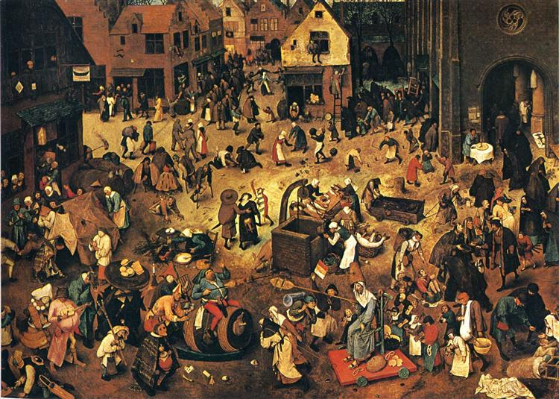
[Pieter Breugel the Elder (1559) The Fight Between Carnival and Lent]

The Possibility in Conviviality:
Telling We-Stories to Our Future?
EICSP – Edinburgh – April/May 2018

4 x 2hr Wonderings: Thursdays - April 12th, 19th and May 3rd, 10th : 2018
Augustine United Church, Edinburgh: 6.45 to 8.45pm

Presented and facilitated by Ian Wight PhD FCIP GTB

For those with a hankering for more than sustainability; for addressing not only our relationship with nature, but also – and perhaps more critically - our relationships with one another: our fundamental inter-relatedness as a culture; the culture that is ours to make.
For folks up for an exploration of the possibility in conviviality – of how we might more mindfully live well together - in these challenging times: practical, proactive, present.
Through some story-telling, with our heart-felt desired future in mind, the future we wish to will into emergence; based on our own soul-stirring experiences of convivial practices - of decency, civility and delight; primed by inspiring poetry, prose and images.

What I wish to maintain here is the idea of an already widespread practice that is integral to our long history, an idea that is diffuse and not collectively recognised: conviviality. Awareness is required so that as many people as possible can mobilise effectively to turn it into a shared reference. It is the foundation of living together properly and it is around this idea that it is possible to organise a future that is better than our present.
Marc Humbert, Towards a Convivial Civilization (2015)

PROGRAM PREMISE: Is it time to bring conviviality more to the fore? For Marc Humbert it is ‘already a widespread practice’, of integral civilizational import, yet active awareness and explicit pursuit seems lacking; a rather ‘diffuse’ idea perhaps – but one that nevertheless seems to very much matter, as a basis for organizing ‘a future that is better than our present’. Might a more convivial civilization be in our future? What practices might serve us, in advancing this collective-life-affirming cause?

In a series of four programmed ‘wonderings’ we convivially explore conviviality, in part as a potentially worthy successor to our now well-established regard for sustainability. We consider the possibility in conviviality – of how we might more mindfully live well together - in these challenging times. We experiment with some story-telling, to our heart-felt desired future, based on our own soul-stirring experiences of convivial practices – of decency, civility and delight, primed by inspiring poetry, prose and imagery.
Sessions Outline

April 12: The Art of Possibility: The Home of Hope?
April 19: A Flourishing Humanity: Well-beings Well-becoming?
May 3: The Possibility in Conviviality: Living (Well) Together?
May 10: The Practice/s of Conviviality: Telling Stories to Our Future?

ASPIRATION: Convening Citizens of/for Convivial Civilization:
A Practice-Story-Telling Circle?

BIO: Ian Wight, a Canadian Scot, has been – in roughly equal measure, over the past four decades or so - an educator of professional planners, and a professional planning practitioner. He is now exploring his re-firement (a re-placing of retirement), kindling his abiding passions, which include a curiosity about the world beyond sustainability - around the possibility in conviviality, as a conduit to planning as placemaking, as wellbeing by design.

True to his Scottish ancestry, Ian loves a really good ‘blether’ (a rich story exchange) that bridges the personal, the professional and the spiritual. In this offering he draws particularly on the inspiration from his experiences with the Adelaide-based Australian Centre for Convivial Backyard Civilization – a ‘blethering-place’ extraordinaire!

[Program offered under the auspices of:]

EICSP
http://www.eicsp.org/

[For more general program resources, provided to participants at the outset, visit: http://ianwight.ca/the-possibility-in-conviviality/ ]

